Methods in artificial intelligence – Assignment 3

Task 2

In this task, I have created a decision support system for helping me choose the next location for my next vacation. I have modelled the problem in GeNIe to help solve the problem. I will now discuss my nodes, choices and different values and probabilities.

The first thing I did was to choose the different Decision nodes. These nodes represent the different choices you can make in your decision problem. The choices I have for my next vacation is:

* I will travel domestic or not
* I will travel with my family or without
* The location is near a beach or not

Figure 1: Decision nodes

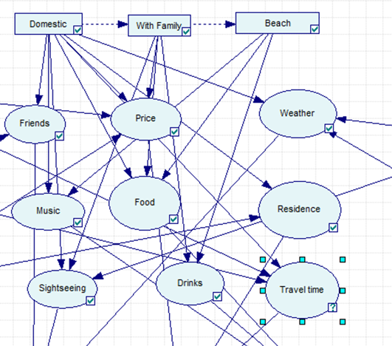After I had decided on the decision nodes, I had to identify the different outcomes of each choice. These are just some of the possible outcomes, but the ones most relevant for my personal choice. Each outcome is represented by a different chance node. The different chance nodes are:

* Make new friends (Friends node)
* Use a lot of money (Price node)
* Experience bad/good weather (Weather node)
* Listening to bad or good music (Music node)
* Eat good/bad food (Food node)
* Find a proper residence (Residence node)
* Go sightseeing (Sightseeing node)
* Have drinks (Drink node)
* Travel distance (Distance)

Figure 2: Chance nodes

Later on, I will assign different probabilities and utilities for the different nodes.

In addition to the decision nodes, there are other variables that can affect the outcomes and thus the chance nodes. I have therefore added some nodes that does not directly affect the final utility, but rather affects the different outcomes. The nodes I have chosen are:

* Travel restriction (Are your travel restricted due to COVID)
* Language (Do you speak the language in the country)
* Popular (Is your chosen destination popular among others)
* Forecast (Is the forecast for your vacation-place bad or good)
* Season (Which season are you travelling in)

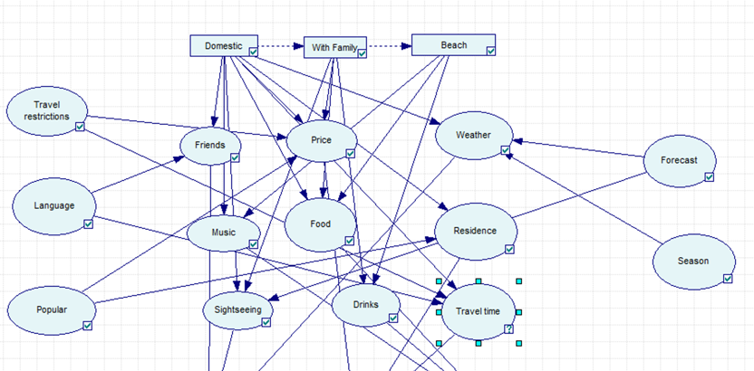

Figure 3: Different chance nodes

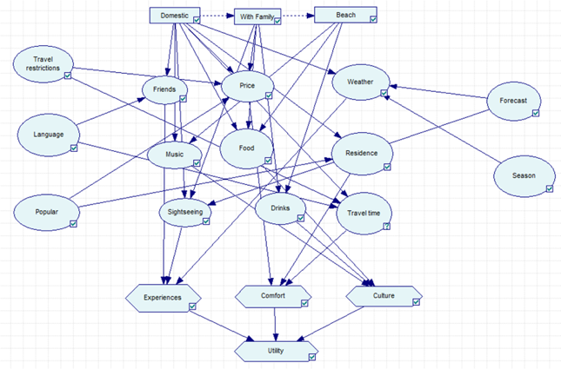The final nodes that are added are the utility nodes. I have decided to split my utility in to 3 different sub-utility nodes and then merge them in to one final node in the end. This made it easier for me to model, and in addition to this, I could weight how much I valued the different sub-utilities. The three different sub-utilities are:

* Culture
* Comfort
* Experiences

Figure 4: Utility nodes

That was all of the nodes, now I can explain the different arcs in the network. The decision nodes do not have any parents. Neither do the nodes that was added after the outcome nodes. These are predetermined states which can be observed before we make the choice. Therefore, I will not add parents to these nodes either. The outcomes have parents that affects the likelihood of the different outcomes. I will discuss some of the decisions on parents to these nodes.

The price node has the most parents, because it is affected by a lot of things. I suspect that if I travel with my family, it will be cheaper. A domestic travel is also usually cheaper, while travelling to a popular place and different travel restrictions can make it more expensive. I also assumed that if I went sightseeing or not depends on the weather. I am also more likely to do it with my family, and also if I travel to a different country. It is also important to find a proper residence. I think there are harder to find in a popular location, and when I travel domestic, there are a great possibility that I travel to our cabin or someone I known’s cabin.

You could think that the travel time was known before you book your vacation and could be one of the predetermined nodes. In my experience, the travel time could vary a lot on the same trip. I made the travel time dependant of travel restriction and domestic travel, both which often leads to shorter travel time. In addition to this, I made it dependant of the language, because if I don’t speak the language, the trip is more likely to become longer (country further away). The food, drinks and music nodes are pretty self-explanatory, so is the weather.

I decided to gather different chance nodes in different utilities. The three utility-types are: experience, comfort and culture. Weather, sightseeing and friends made up the experience utility, travel, residence and price made up the comfort utility, and food, drinks and music made up the culture utility. Splitting up into sub-utilities before gathering them in a final on utility node made it easier to me to set values. It also made it possible to weight the utility I valued the most.

After all of the arcs are set, I quantified the probabilities of each chance node/outcome based on the parent nodes. Because I have 14 chance nodes, and some of the table require a lot of space, I will not include all of the probability tables for all nodes but focus on the most important ones.

I start with the food node, which I regards as an important factor on whether the vacation was a success or not. The food node had to different outcomes: bad food or good food. The result was based on the three parent nodes: domestic, beach and with family. It is a greater chance to get good food when you travel out of the country. This is based on my experiences from different vacation. I am also a fan of the food served on seaside locations, and I will probably get better food in a place by the beach. Lastly, when I travel with my family, I don’t pay myself and we can therefore afford more expensive food which is more likely to be better.

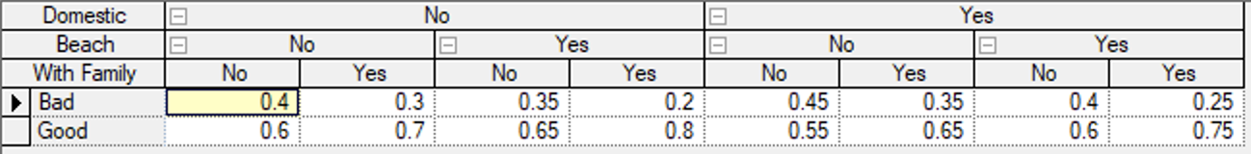

Figure 5: Food node

Another important outcome of a vacation is the total price of the vacation. This is a more complex outcome based on four parents with three different outcomes: cheap, neutral and expensive. The vacation is more likely to be cheap if I travel with my family purely because my parents often pay for food and housing. It is also often more expensive to travel abroad, you have to pay more for the travel. I also assumed that it was more likely to be more expensive if there were no travel restriction when travel abroad because you could travel longer and are more likely to do so after a long pandemic. It is pretty self-explanatory that it is more expensive to travel to a popular destination.



Figure 6: Price node

I will also consider the season node. This node has no parents because the season of the year is not dependant of anything. Based on previous vacations I made the assumption that I am most likely to go on vacation in the summer, because that’s when we have the longest vacation. We also have vacation in the winter, so this is the second most likely outcome. We have a short vacation in the spring, but I don’t travel as often in the easter vacation. I rarely travel in the fall.

Figure 7: Season node

Finally, I will explain the travel time. This is an important factor when I book my holiday. It is pretty obvious that a travel abroad is longer than a domestic travel. I also figured that if the travel restrictions maintains that it will not be possible to travel far, and the travel time will most likely be shorter. The least self-explanatory is that if I don’t know the language, the travel time are more likely to increase. This is because most of the countries close to Norway speaks English, but a lot of countries further away don’t.

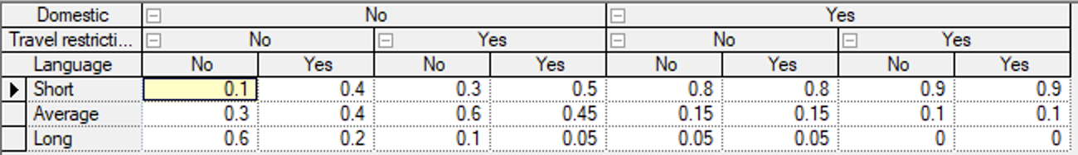

Figure 8: Travel time

It is worth to notice that all of these probabilities are very uncertain. For example, I said that if I travel domestically with my family not to a beach, there are a 45% chance that I will have bad food. This is probably not very accurate, but I had to estimate a value and decided on that.

Now that I have assigned probabilities to each outcome, I can quantify the utilities. As previously explained, I split the outcomes in to three utilities. The first is the experience node. This is the utility from friends, sightseeing and weather. Here I value the weather the most and going sightseeing becomes even better when the weather is good. Making friends does not affect the utility as much as weather and sightseeing, but still makes a noticeable difference.



Figure 9: Experience

The next utility is the comfort, which contains the price, residence and travel time. This is the most complex utility. Here the price and the travel time has the most effect on the utility. This is because I value saving money and not having to spend a lot of time travelling. Those two have a rather big impact on the value. If there are a lot of residences available or not is not so important to me. It is nice to have choices, but it is no crisis to live in a little worse place.



Figure 10: Comfort

The final utility is the culture, which is made up of music, food and drinks. In this utility the food has the most effect on the value. But the combination of good food, good music and drinks gives a high value.



Figure 11: Culture

Finally, I collect all of the sub-utilities in a final utility. This will give me a calculation on which vacation I should book next. In addition to the sub-utilities, I decided to weight the different sub-utilities. I chose to do this because I value culture the most, and experiences second. The result was, not surprisingly, that my next vacation should be abroad, with my family by the beach. What is interesting is that if I don’t travel with my family it is better to go to the beach if I am abroad, but not if I am in Norway. But it is always better to go to a place by the beach if I travel with my family.



Figure 12: Final result

This result is based purely on the probabilities I decided on. But when I make a choice there are often a lot of the chance nodes that could be checked before deciding. Therefore, I decided to add evidence to the calculation. Imagine it is winter, the forecast is good, and I want to travel to a popular place. Then it is better to travel in Norway. It is still better to travel with my family. What is interesting is that it still suggests that it is better to travel to a place with a beach. This indicates that my network may not be optimal, because I would not prefer to travel to the beach in the winter. Abroad would be nice, but I don’t think that a beach vacation in Norway in the winter is the best vacation.

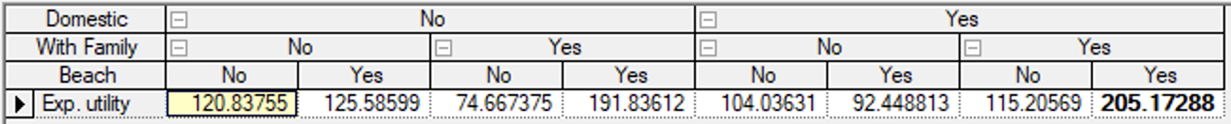

Figure 13: Utility with evidence

After trying out the network with different evidence, I found out that it is usually best to travel with the family. This is probably because it affects the price and the food a lot, and these are two outcomes that have great effect on the utility. The exception is that it is usually better to go to the beach abroad without the family, something I can agree with.